Research
Collectively, we investigated various websites. This included HSS Australia, St. Johns, Volunteering SA&NT and Food Bank. This gave us a rough idea of how we wanted our main pages to look, and what sort of content the pages included. With this information we were able to conclude aspects of websites which worked well and what didn’t, allowing us to pick and choose what we wanted on our site and what we don’t.

First thing we noticed was the colour scheme in all the websites we researched remained consistent though out all the pages, allowing them to flow well, provided the user a coherent experience whilst browsing the sight.

Another common trend we observed was the main, or home pages on the sites didn’t include much information, most home pages had large images and bold texts to capture the user’s attention. We noticed in most sights that the navigation bar at the top of the page included all the different pages. In most sights the navigation bar was present in all pages, allowing the user to travel through the site swiftly and efficiently.

Each example was carefully selected based on how effectively it met user needs and the clarity it provided in navigation and information access, justifying their inclusion in our design blueprint

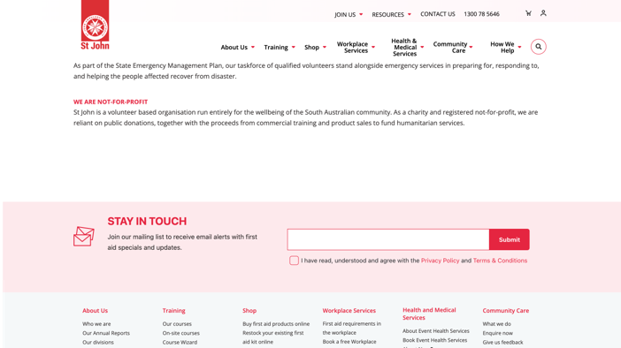
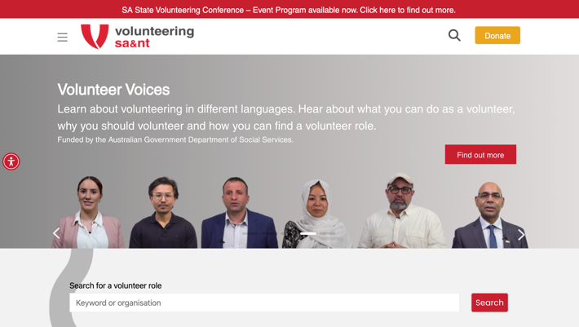
St. Johns

Volunteering sa&nt
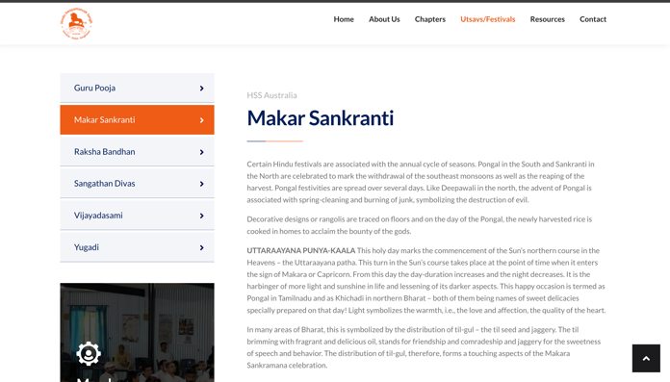
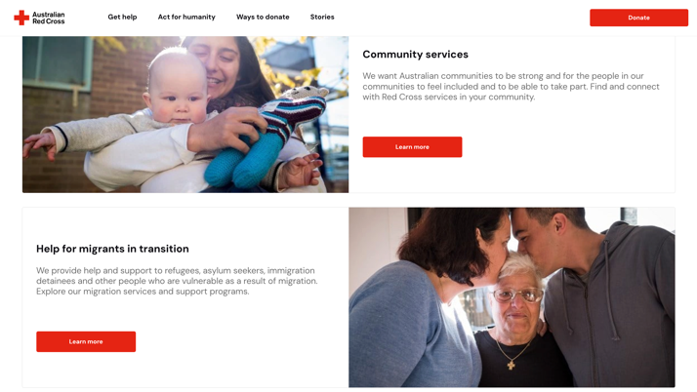
HSS Australia
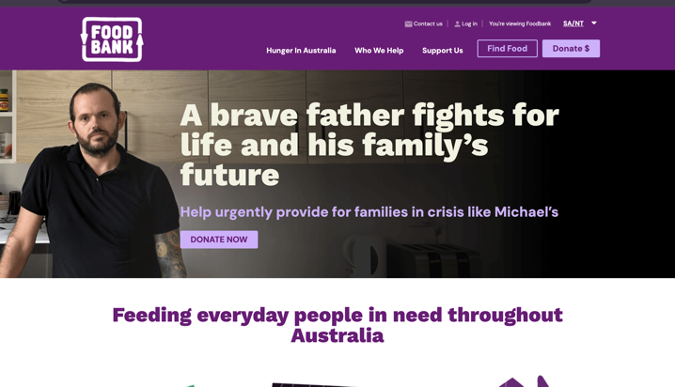
Australian Red Cross
Food Bank Australia

There were several common pages we noticed in these websites. The few other pages were related to the niche of the website. Noting down this common theme, we decided to include a main page, log-in/sign-up page, about page, profile page, and events page. We noticed how most of these had been lined up on the main page instead of a drop-down menu. We found both styles appropriate for our concept however, we planned to go with the common theme in our research, which was presenting all pages at once on the header.

Upon deciding this, we planned to split the relevant features and pages we needed into these 5 pages. The profile page would include the features the 3 types of users could utilise.

Design + Features:
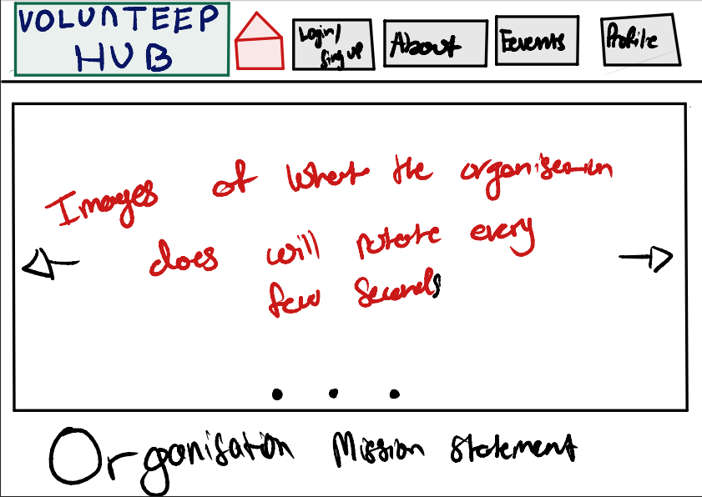

These our initial sketches for our website. ‘Volunteer Hub’ is a rough idea for the name; however, we may change it after further review. We plan to base our website on an organisation that helps communities by providing food.

This is our main page. We decided to have a fix header with the title/logo, a home button, login/sign-up page, about page, events page, and profile page. These will remain constant throughout each of the pages.

Drawing inspiration from the ‘Volunteering sa&nt’ website, we wanted to display a slideshow feature with the mission statement of our website on the bottom. We plan to have components which re-size using relative sizing measurements throughout our website.

The header and footer both stretch across the width of the screen. Their height will ideally be set around 40-60px to ensure it will fit all the navigation buttons. The main content area will be dynamically sized, taking up the remaining space between the header and footer. It will feature a minimum width of 300px to ensure content remains clear and accessible on smaller devices.

The features we plan to have on this page would be just about the slideshow. When the user clicks on the arrow, it should display the next image, if not, automatically every few seconds the images move through.

For the fixed headers, the features will be common. The accessibility of pages is laid out individually instead of putting it together in one drop down column. The reason for this is because we wanted to minimise the number of the main pages required. We did this through sorting out the features and information under the necessary main pages, which will be shown in the other designs. The logo, we plan to add a border to showcase the user what page they are on.

Whenever the user uses the cursor to the hover over the logo or the pages tab on the header, we plan to add a slight hover effect which would just add a nice visual appeal to it. This was a common theme on all these pages that we visited.
Another feature implementation we plan to add is that the logo and buttons will be hyperlinked, so the users can access whatever page they want. This will be implemented on all the pages.
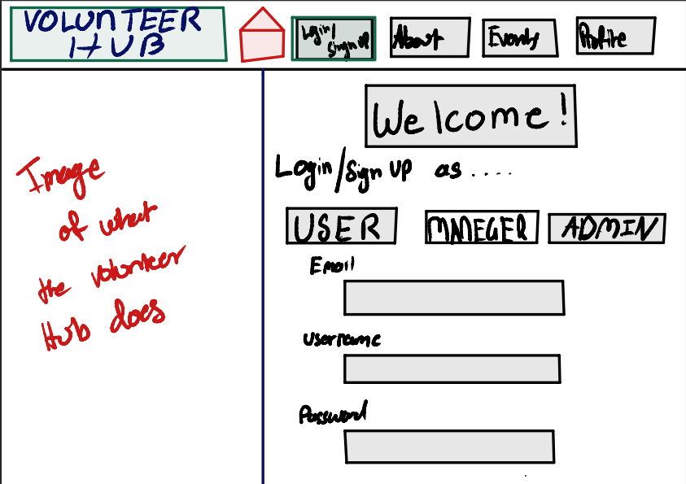

As it can be seen on the header, the login/sign-up page is highlight in the colour green. This is done so the user is indicated on what page they are on.

We wanted to a minimalistic approach on this page but something that looks appealing too. A basic login/sign-up page includes a username, email, and password.
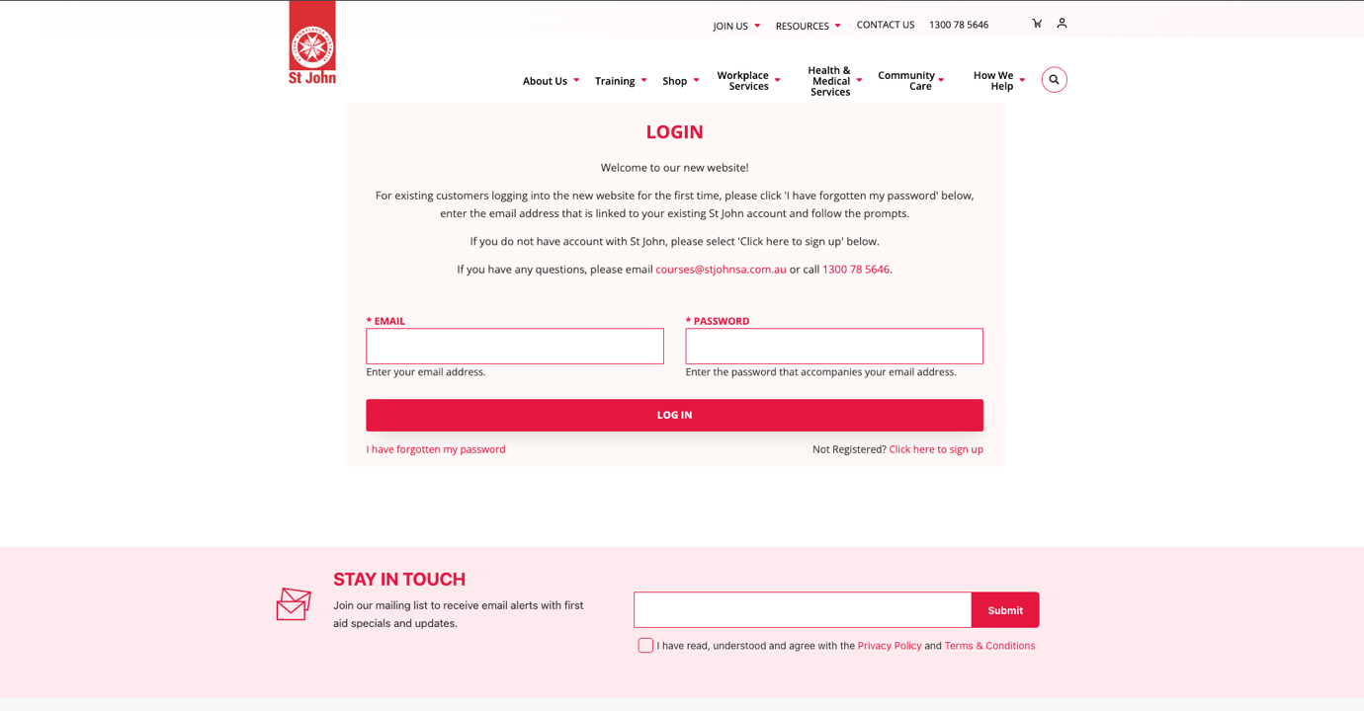

Using this as a guide, we tweaked this layout by adding an image feature. The user, manager, and admin can use their own unique username, email and password to login-in or sign up. Whatever type of user, all they need to sign-up is just the 3 things mentioned above. The reason for this is because each type of user has different profile information’s such as unique id for managers verses to system admins, therefore, they can just edit that in the profile page, depending on the type of user.

Once they log-in, they will be directly lead to the profile page. Again, the green highlight is there on the profile page, helping the user know what website they are on. Similarly, the different parts of the profile page is organised in a single column, in which the green highlight is utilised again to indicate which section of the about page the user is in.

The ‘Stay in touch’ feature was appealing to us as we wanted to implement this special feature in our website. However, we felt this was appropriate to do it on the About Us page as it would be relatable there and our minimalistic approach to this page would remain consistent.

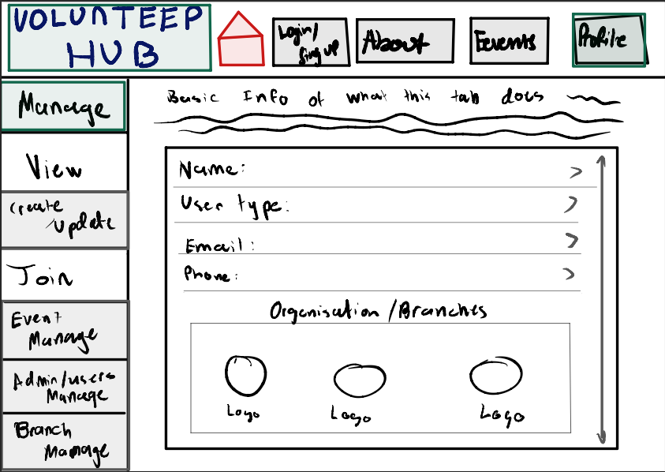

Now this sketch is designed as if the normal user was logged in. Therefore, some of the sections in the column have been greyed out, which means the user will not have access to these. They will simply not be clickable.

As we were required to have different types of users, which are required to execute different tasks such as manage organisation branches or manage events. The way HSS Australia have organised their different festivals in one column, we felt this was an excellent way we could organise our own profile page, which has many features such as managing profile or organisations.

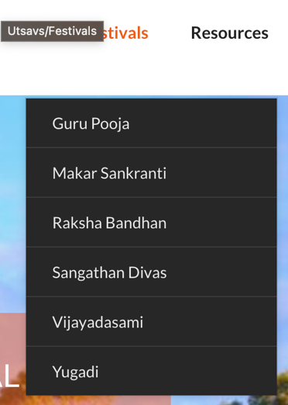

The manage tab will look almost similar for the all the users. This includes the basic information of the user and the different branches of the organisations visible. Here the users can edit their information by clicking on the arrows to edit. There is scroll wheel for the information as this depends on the sizing we decide to use when creating the website. .

According to the feature requirements, the basic user can join and view organisations events. Therefore, they have access to these tabs. These tabs include viewing any updates from the organisations of the events information can already be accessed through the events page. The Join tab will have the feature to Join events by RSVPing to them. They will be organised into boxes with individual scroll options, so the information is organised.

For the managers, they have access to the create/update tab and the event manage tab as they are required to have access to these features. Managers will be able to create and update events in this tab, and there will be two boxes similar to the viewing tabs. This will be a consistent theme among all the tabs in the profile page as this helps organise related information together and is visually appealing. To create an event, there will be a button implemented that when it is clicked it will ask the user to input title, description, location and date. Then in the ‘Update Event’ box, a clickable label by the event name will appear which will be editable.

The event mange tab will have the feature of posting public and private members, again in two different boxes. When an update is made, the view tab will receive this update and be shown to the normal user logged in, as required by ‘Feature Details’.

For the system admins, the branch managers, and admin/users manage tabs will be available. In this they can edit the information as required by the ‘Feature Details’. This will be signing up other admins via a similar method of the creating and editing an event, but signing up other admins. The branch manage tab will show the different branches of our website, with the different events within these branches. These will be in form of a button which when clicked on it, admins will be able to edit the information.

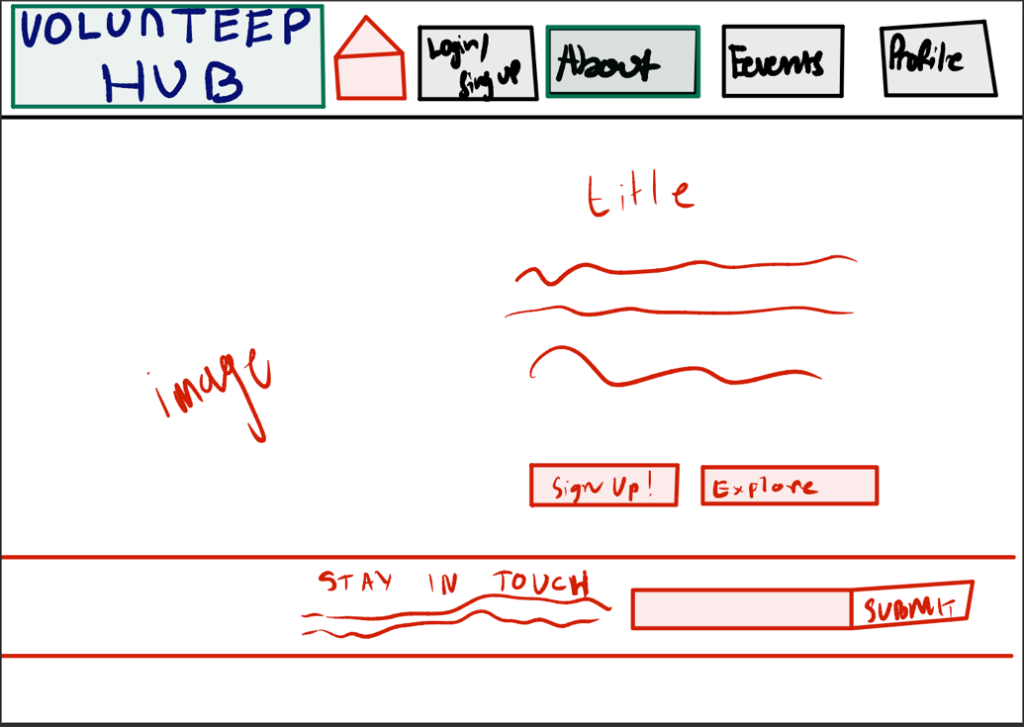

The sketch depicts the layout for an 'About' page of the website. This page is designed to provide visitors with information about the organisation and encourage user engagement.

The navigation bar at the top stays consistent helping facilitate easy navigation across the website and a user-friendly design. The title below the navigation bar would typically feature a large text that summarises the purpose of that page such as “About us” or “Learn about us”. The main image on the left side of the page will be a meaningful image that represents the organisation. This image will effectively portray the organisation’s mission of supplying food to the less fortunate.

The text underneath the title will describe the organisation’s purpose and how they work. This section could also include the history of the organization, its goals, achievements, and any other relevant information about its activities and impact. There are two call-to-action buttons underneath the text, “Sign Up!” and “Explore”. These are designed to engage visitors further by encouraging them to register as volunteers and explore more about specific programs or events.

At the bottom of the page, there's a dedicated section for visitors to subscribe to updates or newsletters. It includes a placeholder for entering an email address and a "Submit" button, ensuring the organization can maintain contact with interested parties. Here we plan to implement the 1 of the 3 special features as outlined in the Feature Requirements which is the email notification system.

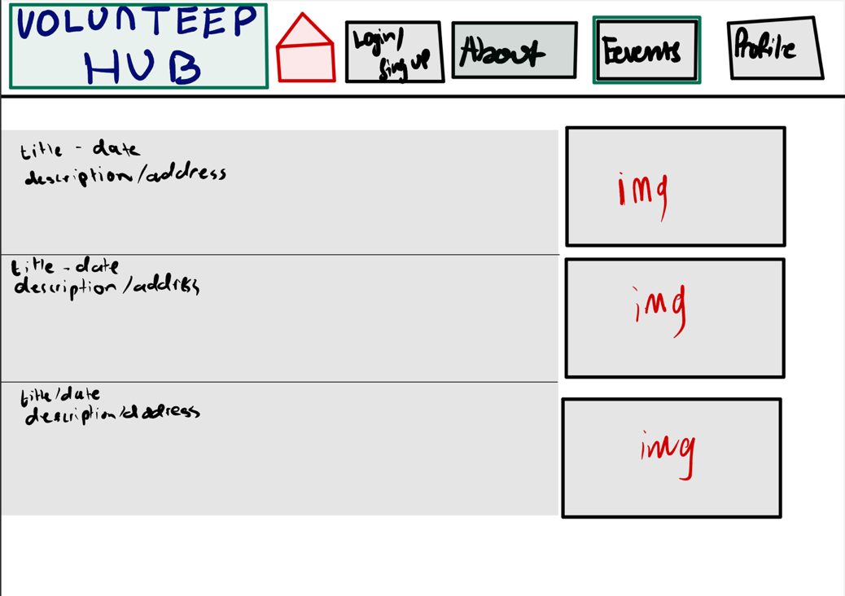

This is the Events page that will show case the details of the separate events or activites. The purpose for this page is to showcase the events our organisation is hosting. Users can click on either the image or the text, and they will be led to the profile page, and in the ‘Join’ column. They can RSVP via this method.

What we found to be a good way of putting information was through the Australian Red Cross website. The use of images, a bit of description and a learn more process which would navigate the user to the page with the complete information. This way the necessary information is organised efficiently and displayed well for the user.
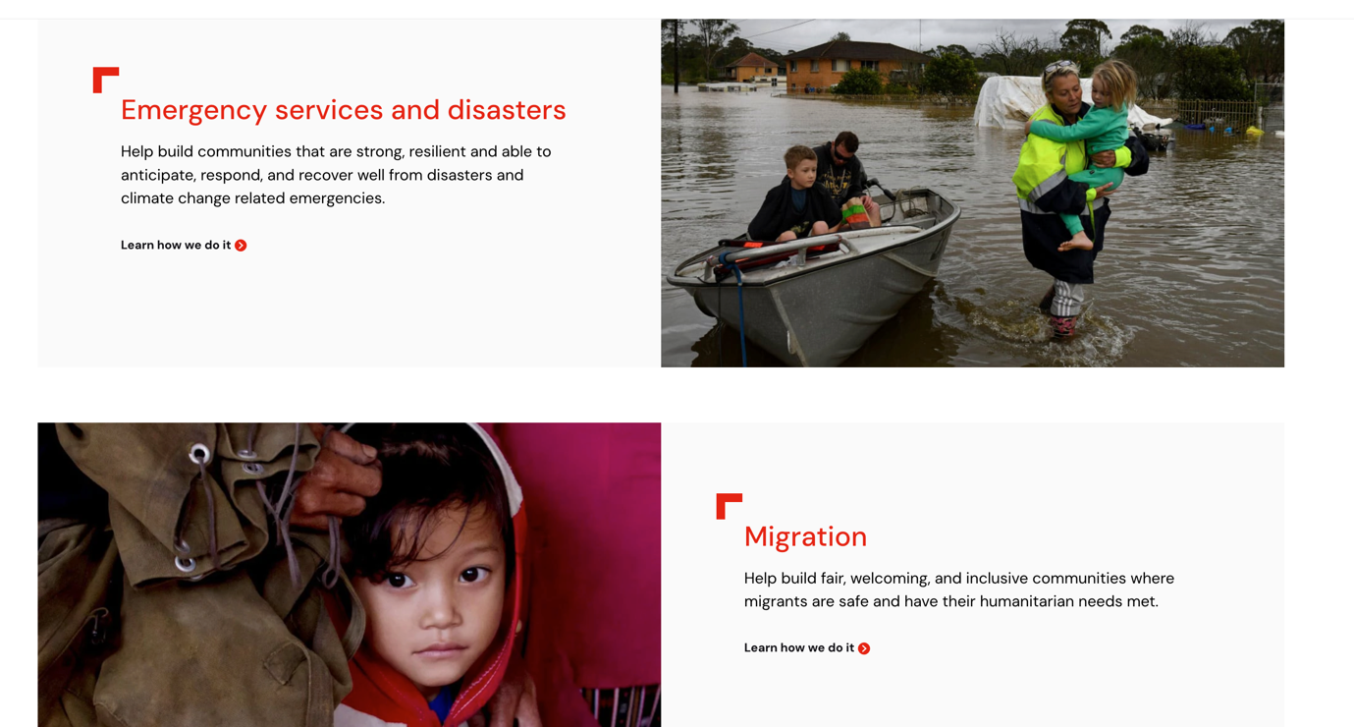

Review.

The design principles presented here are intended to reduce kinematic and cognitive demands in order to improve user experience. Respecting usability guidelines and best practices guarantees a smooth and easy-to-use website experience.
Minimising Kinematic Load:
Simplified navigation by having a dedicated header for each page and tabs in column in the profile page. The navigation bar provides clear options in the form of buttons such as “About” or “Events” which will highlight when they hover over it and would also minimise the number of clicks to access the different pages. Placements of the buttons such as the Sign Up on the About Page are placed prominently, making them easy to find and click. Scrolling is minimised as most key information and actions are about the fold of the page, reducing the need for excessive scrolling. The design also minimizes the need for excessive mouse movements or clicks as essential functions are accessible within one to two clicks from any page.

Minimising Cognitive Load
The mental strain needed to operate the interface is referred to as cognitive load. This is addressed by the design through. Links and buttons have labels that make it obvious what they do (such as "Sign Up," "Explore," and "Submit"). Users can develop mental models of where to obtain information by using buttons and navigation elements that are consistently placed. Users' attention is successfully guided by the hierarchical arrangement of buttons, graphics, and titles.

Standards and Heuristics
Visibility of System Status: Users are always aware of where they are on the website thanks to the section headers and navigation bar.
Match between System and the Real World: The platform uses language that is familiar to the users, such as "sign-up" for events and "dashboard" for user profile management, making the website’s functionality intuitive.
User Control and Freedom: Users can freely navigate between parts without feeling constrained.
Consistency and Standards: Consistency and Standards: UI elements and operations are designed to be consistent throughout the platform. For example, the website follows a consistent colour theme and keeps certain elements such as header and footer consistent, this avoids the user from feeling overwhelmed with new information or unfamiliar elements.
Error Prevention: Clearly labelled buttons and large text make mistakes by users less likely.
Recognition Rather Than Recall: Users don't have to recall as much information because they can quickly view all the possibilities.
Flexibility and Efficiency of Use: The design's user-friendly interface accommodates both inexperienced and seasoned users.
Help and Documentation: This heuristic would be supported by sections such as "About" as it provides information to the user.

Peer Feedback on Designs:

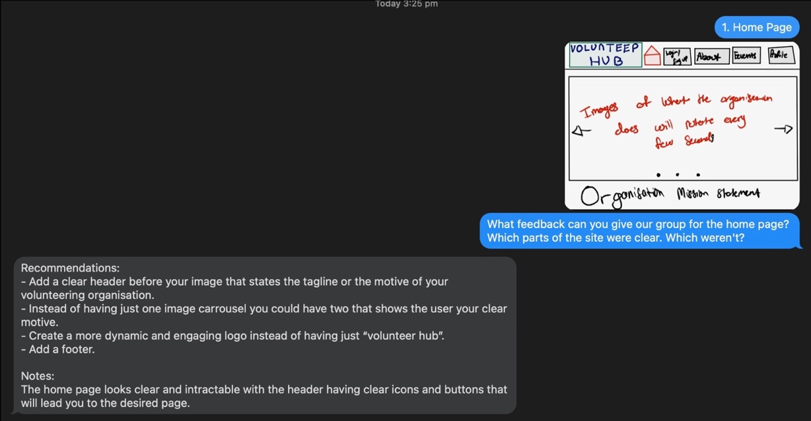

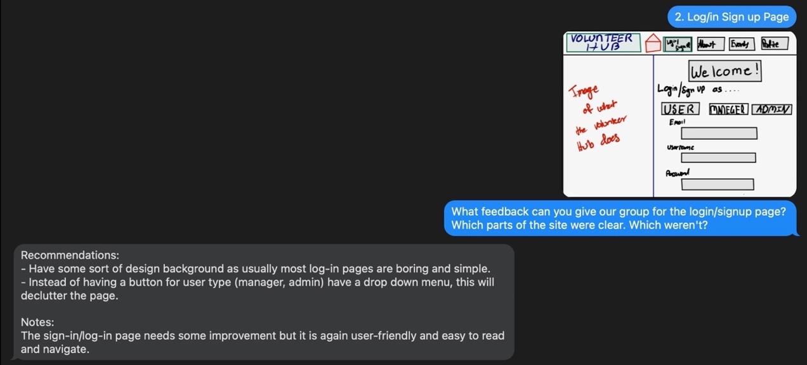

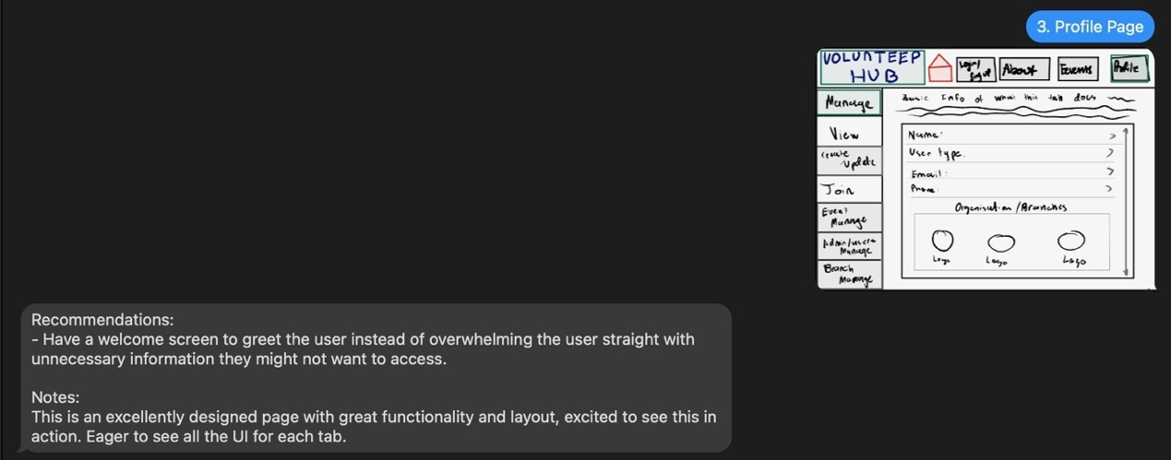

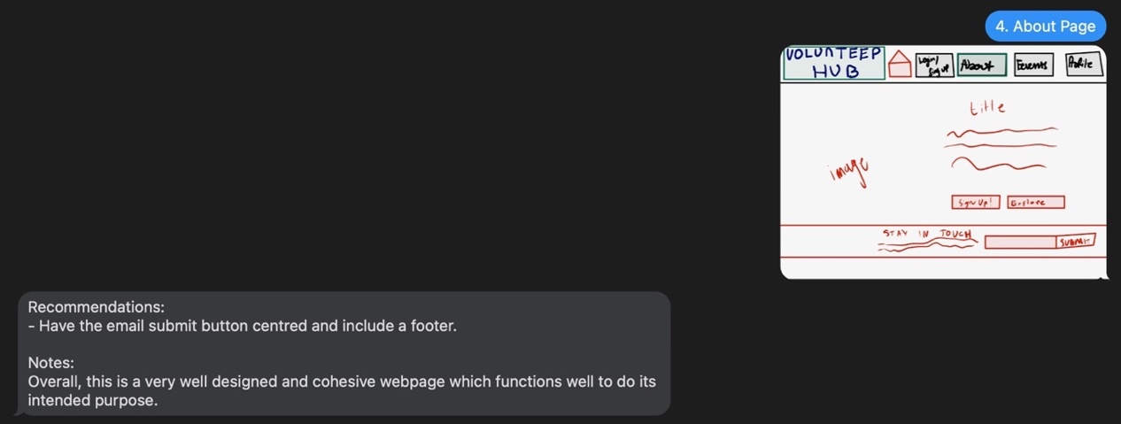

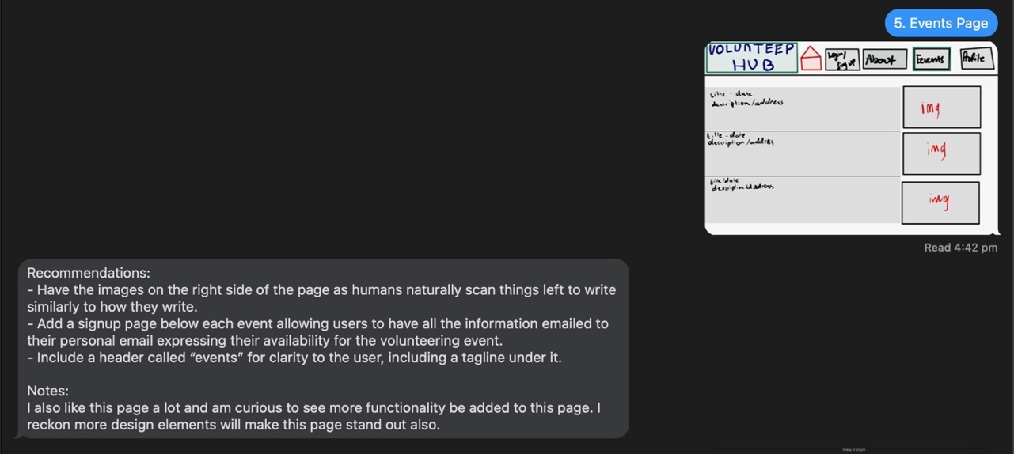

Review +Change)

Home Page:
The feedback provided on the initial sketch for the home page was implemented effectively. The homepage now includes a captivating header with the organisation’s motto, “Cultivating Connections, Nourishing Communities”, capturing the user’s attention whilst also communicating the organisations’ goal. Multiple image carousels are used to showcase multiple visuals of what the organisation does providing a dynamic and engaging feature to the website. The logo of the website is now “Food Link Australia”, including a colourful and attractive image, improving the overall aesthetic of the home page. Additionally, a footer has been included, which much like the header will remain consistent throughout the pages of the site. The foot contains navigation links and contact information, improving user experience, and increasing ease of use. These changes created a clear, eye-catching home page which communicates the theme and mission of the organisation well.
Login/ Signup
The feedback on the sketch for the login/ sign up page suggested adding a captivating background, replacing the buttons with a drop-down selection menu for user types and ensuring the page is user friendly. These recommendations have been taken upon and incorporated into the current website. The login/ sign up page has been mortified to become more attractive and captivating through its gematric background. The user type options have been changed from buttons to a drop-down menu, this reduces cluttering with the interface. The login/ signup page is user-friendly and easy to navigate, it has clear input fields and a welcoming layout.

Profile Up
The feedback on the profile page sketch suggested to have a welcome screen to greet the user and present the overwhelming them with a large amount of information as soon as they enter the page. This feedback was implemented on the current website design. The profile page now has a welcome page as well as a sectioned offside bar that is well organised allows used to access different sections of the page such as managing user information, viewing updates, creating, or updating events, and joining events. Each section is labelled clearly, easy to navigate, ensuring a use friendly experience. The inclusion of these feature has allowed the profile page to be well designed, functions and visually clear.

About Page
The feedback for the about page recommended cantering the email submit button and the addition of a footer. The reset of the page was a simple yet effective deign. The “Stay in Touch feature is not centred bringing the page together, making it more visually balanced and accessible. In addition, the footer which has been included in all the other pages has also been added, remaining consistent with the rest of the site and also enhancing the usability through another port of navigation. The overall design of the page maintains a clear functional aesthetic with a clear tittle, image, and a call-to-action button, effectively fulfilling the purpose of an “about page”.

Events Page
Feedback on the first drawing of the events page included adding a signup button for each event, aligning photos to the right, and creating a header labelled "Events" with a catchphrase. The present design has taken these suggestions into consideration. In keeping with natural reading patterns, the events page now has a prominent "Events" header and tagline, with photographs positioned to the right of the event descriptions. Users can easily express their availability by clicking the "Sign Up" button and reading the complete description that is included with each event listing. These updates improve the usability and functionality of the page and are in line with the input that was given.

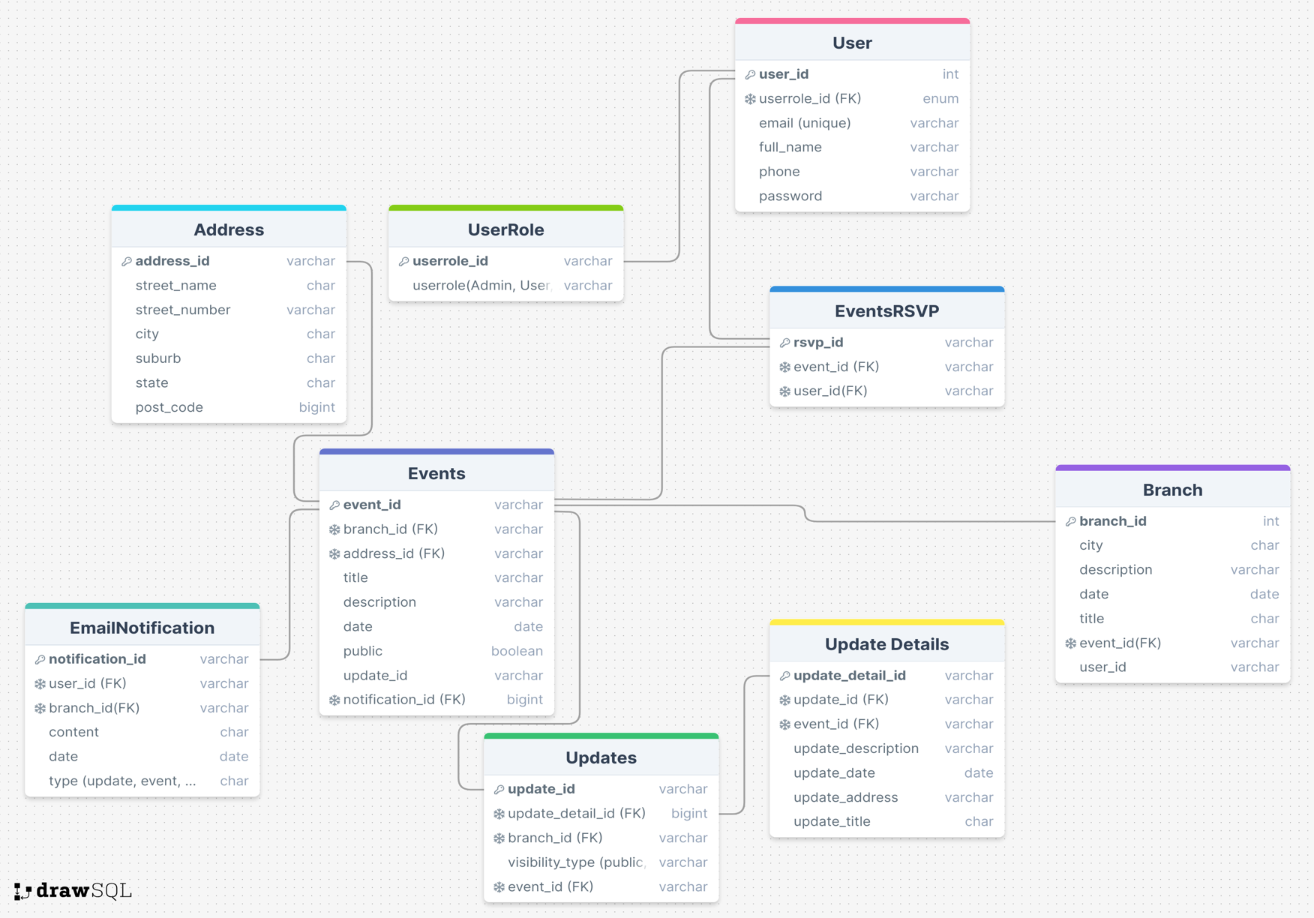

One to One Relations:
- One Event can only have One Address

One to Many Relations:
- Each user can have multiple roles (admin can make user managers), but multiple roles cannot be assigned to one user.
- One branch can host many events, but many events cannot be part of the same branch (like event in Adelaide can’t be part of a Brisbane branch)
- One user can have many notifications.
- One update can have many update details.

Many to Many Relations:

- Users can be associated with many branches, and many branches can have many users.
- Users can RSVP to many events and Events can have many RSVP.
- Updates can be part of many branches and many branches can have many updates.

